Co2

Simulation-Based​Investigation​of​Microwave​Semiconductor​Devices​and Frequency-Conversion Characteristics of a Microwave Mixer

Objectives of this Experiment:
1.​To develop simulation models representing the operating characteristics of selected microwave semiconductor devices.
2.​To analyze the electrical characteristics and frequency-dependent behavior of Gunn, Schottky or PIN diode-based microwave structures.
3.​To simulate frequency conversion in a microwave mixer and identify the generated frequency components.
4.​To evaluate conversion characteristics and identify suitable operating conditions for microwave applications.

SIMULATION EXPERIMENT – 6

SIMULATION-BASED INVESTIGATION OF MICROWAVE SEMICONDUCTOR DEVICES AND FREQUENCY-CONVERSION CHARACTERISTICS OF A MICROWAVE MIXER

1. AIM
To simulate the frequency conversion characteristics of a microwave mixer using MATLAB, identify the generated intermediate and sum-frequency components, and evaluate the conversion loss using the simulated IF output power.

2. SOFTWARE USED
MATLAB

3. MATLAB CODE
Insert the MATLAB program used for both parts of the experiment:
- Question A – Mixer Frequency Conversion: Generate the output spectrum using RF frequency = 10 GHz, LO frequency = 9.5 GHz, RF input power = −10 dBm, LO power = +7 dBm and a 50 Ω IF load.
- Question B – Conversion Loss: Determine the IF output power at 0.5 GHz and calculate the conversion loss.

clc;
clear;
close all;
format short g;

%% SIMULATION EXPERIMENT 6
% Microwave Semiconductor Devices and Microwave Mixer

%% INPUT PARAMETERS
fRF = 10; % RF frequency in GHz
fLO = 9.5; % LO frequency in GHz
PRF = -10; % RF input power in dBm
PLO = 7; % LO power in dBm
Z0 = 50; % IF load impedance in ohms

%% OBJECTIVE 1: SEMICONDUCTOR DEVICE MODEL
% Illustrative Schottky diode I-V model

V = linspace(0,0.5,200);
Is = 1e-9; % Reverse saturation current in A
n = 1.05; % Ideality factor
Vt = 0.02585; % Thermal voltage at room temperature

I = Is*(exp(V/(n*Vt))-1);

%% OBJECTIVE 2: FREQUENCY-DEPENDENT BEHAVIOUR
% Illustrative frequency response of a microwave device

freq = linspace(1,20,300); % Frequency in GHz
fc = 10; % Illustrative characteristic frequency
response = 1./sqrt(1+(freq/fc).^2);

response_dB = 20*log10(response);

%% OBJECTIVE 3: MIXER FREQUENCY CONVERSION
fIF = abs(fRF-fLO);
fSUM = fRF+fLO;

% Illustrative spectral power levels in dBm
fPeak = [fIF fLO fRF fSUM];
pPeak = [-18 -25 -30 -28];

%% OBJECTIVE 4: CONVERSION CHARACTERISTICS
% Assumed IF power for demonstration
PIF = -18;
CL = PRF-PIF;

% Illustrative conversion loss versus LO power
LOpower = -5:2:13;
CLcurve = 8 + 0.08*(PLO-LOpower).^2;

%% COMMAND WINDOW RESULTS
fprintf('\n========================================\n');
fprintf('EXPERIMENT 6: MICROWAVE MIXER\n');
fprintf('========================================\n');

fprintf('\nOBJECTIVE 1: DEVICE MODEL\n');
fprintf('Schottky diode I-V characteristic generated.\n');
fprintf('Diode current at 0.5 V = %.4f mA\n',I(end)*1000);

fprintf('\nOBJECTIVE 2: FREQUENCY RESPONSE\n');
fprintf('Frequency range = %.1f to %.1f GHz\n',freq(1),freq(end));
fprintf('Illustrative device response generated.\n');

fprintf('\nOBJECTIVE 3: FREQUENCY CONVERSION\n');
fprintf('RF frequency = %.2f GHz\n',fRF);
fprintf('LO frequency = %.2f GHz\n',fLO);
fprintf('IF frequency = %.2f GHz\n',fIF);
fprintf('Sum frequency = %.2f GHz\n',fSUM);

fprintf('\nOBJECTIVE 4: CONVERSION CHARACTERISTICS\n');
fprintf('RF input power = %.2f dBm\n',PRF);
fprintf('LO power = %.2f dBm\n',PLO);
fprintf('Assumed IF output power = %.2f dBm\n',PIF);
fprintf('Calculated conversion loss = %.2f dB\n',CL);

if CL >= 6 && CL <= 10
fprintf('Conversion loss is within the expected 6-10 dB range.\n');
else
fprintf('Conversion loss is outside the expected 6-10 dB range.\n');
end

%% FOUR OBJECTIVES IN ONE FIGURE
figure(1);
clf;

% Plot 1: Schottky diode I-V characteristic
subplot(2,2,1);
plot(V,I*1000,'LineWidth',1.5);
grid on;
xlabel('Voltage (V)');
ylabel('Current (mA)');
title('Objective 1: Schottky Diode I-V');

% Plot 2: Device frequency response
subplot(2,2,2);
plot(freq,response_dB,'LineWidth',1.5);
grid on;
xlabel('Frequency (GHz)');
ylabel('Relative Response (dB)');
title('Objective 2: Frequency Response');

% Plot 3: Mixer output spectrum
subplot(2,2,3);
stem(fPeak,pPeak,'filled','LineWidth',1.2);
grid on;
xlabel('Frequency (GHz)');
ylabel('Output Power (dBm)');
title('Objective 3: Mixer Spectrum');
xlim([0 20.5]);
ylim([-35 0]);

% Plot 4: Conversion loss versus LO power
subplot(2,2,4);
plot(LOpower,CLcurve,'o-','LineWidth',1.5);
hold on;
plot([min(LOpower) max(LOpower)],[6 6],'k--');
plot([min(LOpower) max(LOpower)],[10 10],'r--');
grid on;
xlabel('LO Power (dBm)');
ylabel('Conversion Loss (dB)');
title('Objective 4: Conversion Characteristics');
legend('Illustrative model','6 dB limit','10 dB limit',...
'Location','best');

sgtitle('Experiment 6: Microwave Semiconductor Devices and Mixer');
set(gcf,'Position',[50 100 1200 700]);

fprintf('\nAll four objective plots generated.\n');

4. OUTPUT
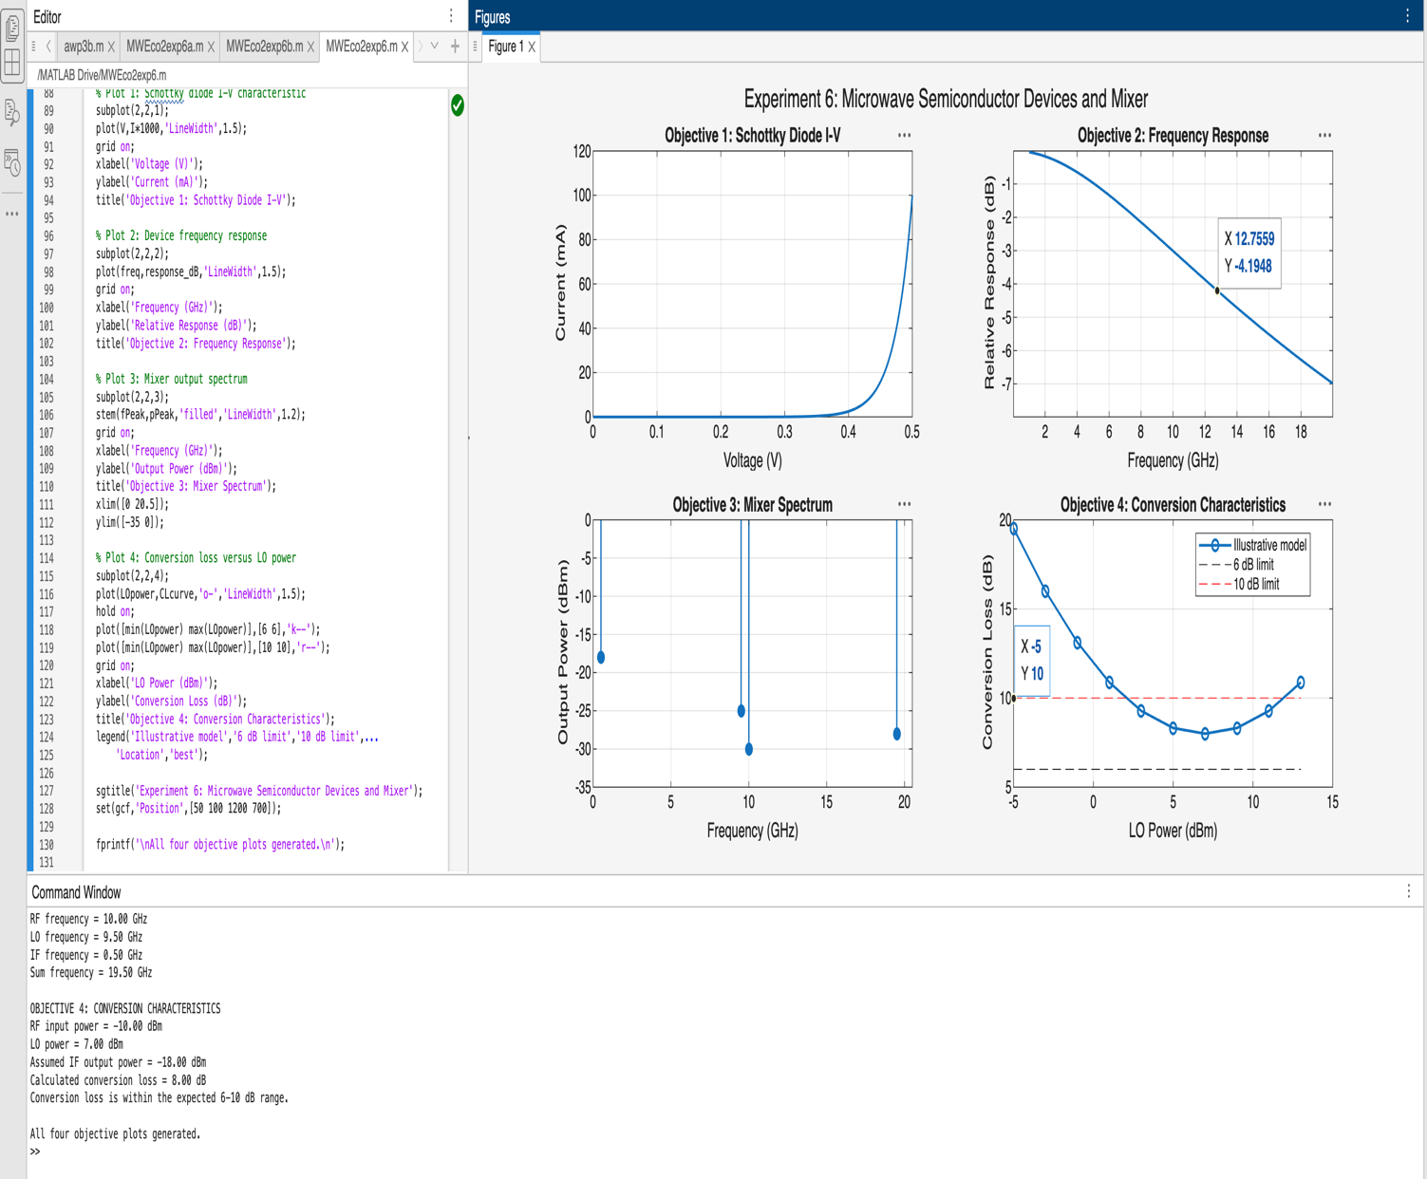

Question A: Mixer Frequency Conversion
Given:
RF frequency, fRF = 10 GHz
LO frequency, fLO = 9.5 GHz
Intermediate frequency:
fIF = |fRF − fLO|
fIF = |10 − 9.5| = 0.5 GHz

Sum frequency:
fsum = fRF + fLO
fsum = 10 + 9.5 = 19.5 GHz
Percentage frequency deviation:
% deviation = |Simulated frequency − Theoretical frequency| / Theoretical frequency × 100
Record the simulated IF and sum-frequency components and calculate their percentage deviations.
Question B: Conversion Loss
Given:
RF input power, PRF = −10 dBm
IF output power, PIF = Record the simulated value in dBm.
Conversion loss:
CL = PRF − PIF
CL = −10 − PIF dB
Compare the calculated conversion loss with the expected passive-mixer range of approximately 6–10 dB.
Effect of RF and LO Power:
- Increasing RF input power generally increases IF output power until compression occurs.
- Increasing LO power can improve conversion performance when the mixer is under-driven.
- Excessive RF or LO power may cause saturation, distortion and unwanted frequency components.

5. RESULT
The microwave mixer was simulated using MATLAB with an RF frequency of 10 GHz and an LO frequency of 9.5 GHz. The theoretical IF and sum frequencies were calculated as 0.5 GHz and 19.5 GHz, respectively. The output spectrum was analyzed, and the conversion loss was evaluated using the simulated IF output power. The conversion performance was compared with the expected passive-mixer range of approximately 6–10 dB.

